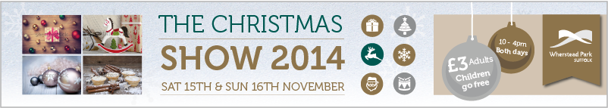

15th & 16th November 2014 - Booking Form

|  |  |
| --- | --- |
| Company Name: |  |
| Contact Name (Mr/Ms/Miss/Mrs): |  |
| Product(s) to be exhibited: |  |
|  |  |
| Contact Address: |  |
|  |  |
| Telephone: |  |
| Email: |  |
| Website: |  |
| Billing address, if different from above: |  |
|  |  |

*Please tick the stand size and location you require:*

|  |  |  |  |
| --- | --- | --- | --- |
| **Location** | **Exhibition stand size** | **Price** |  |
| Atrium | 1 x 6ft x 2ft table | £150 inc. VAT |  |
| Atrium | 2 x 6ft x 2ft table | £260 inc. VAT |  |
| Mansion | 1 x 6ft x 2ft table | £160 inc. VAT |  |
| Mansion | 2 x 6ft x 2ft table | £280 inc. VAT |  |

|  |
| --- |
|  |

*How many tables do you require? ­­­­­­­­­­­­­­­­­­­­­­­­­­­­­­*

*Do you have any of the following requirements?*

|  |  |  |  |  |  |  |
| --- | --- | --- | --- | --- | --- | --- |
|  | Y/N | No. |  |  | Y/N | No. |
| **Power outlet** |  |  |  | **Table cloth** (£7.25 inc. VAT) |  |  |

*Please outline any additional requirements:*

|  |
| --- |
|  |

**Declaration:** Please accept this booking form as confirmation that we have read the Terms and Conditions provided and will be attending the Christmas Show with the products listed above.

|  |  |
| --- | --- |
| Signed: |  |
| Print: |  |
| Date: |  |

*Please return your completed forms either by email to* [*bookings@whersteadpark.co.uk*](mailto:bookings@whersteadpark.co.uk) *or by post to The Events Team, East of England Co-operative Society, Wherstead Park, The Street, Wherstead, Ipswich, IP9 2BJ.*



**TERMS & CONDITIONS**

1. Once a stand is booked the full charge is due, whether or not the booking is subsequently cancelled.
2. A standard single size stand includes a 6ft by 2ft table, with a 1ft gap to the next table- top stand. There is room for a pop-up banner stand behind. The table is provided with 2 chairs. Stand-holders can choose to dispense with the table and chairs if they wish to create your stand area using pop-up banner stands and other collateral.
3. Stand-holders will commit to selling only the product types listed on their booking forms.
4. The size limits for accessing the exhibition area are limited by the size of the access doors from the pavement. Most stand holders are therefore restricted to entering the doorway which is 2.25m wide and 2.1m high.
5. Access for the show can be made to the venue from **Midday** on **Friday** **14th November** until **6pm.**
6. Access to the venue on the day of the show commences at **7am.**
7. It is the responsibility of the stand holders to ensure that there is no damage caused by the delivery, setting up, dismantling or removal of the stand to the venue. Any damage will be the responsibility of the stand holder and may result in a subsequent repair charge.
8. All stand holders must have their stands dismantled and cleared away by **6pm** on the day of the show.
9. There is a very limited storage space for stand banners and collateral overnight and so storage for deliveries the night before or the following morning after the show cannot be assured.
10. All stands and other material brought to the show must be removed from the venue. Unused brochures and other collateral cannot be left at the venue for disposal. Any such surplus resource left at the venue may attract a disposal charge of up to **£30 plus VAT.**
11. Stand-holders are responsible for any materials delivered to or made from the venue and for their materials and possessions during the show. The venue accepts no responsibility or liability in that regard.
12. All stands have access to at least one 13 amp electricity socket, provided advance notice. Any additional power needs must be raised with the organisers well before the event to enable your needs to be met.
13. The table-top stands do not come “dressed”. If you wish to have a table cloth for the table, then this is available from the venue prior order at a fee of **£6 plus VAT.**
14. Stand-holders will be invoiced upon receipt of the booking form.